Batch: B3 Roll No.: 16010122158

Experiment No. 03

TITLE: Demonstrate the use of Bootstrap

AIM: To use bootstrap (open source front-end development framework) for the creation of web pages.
_____________________________________________________________________
Expected Outcome of Experiment: Re_design of web pages using various HTML, CSS tags with bootstrap.
________________________________________________________________
Books/ Journals/ Websites referred:

http://getbootstrap.com/getting-started
_____________________________________________________________________

Problem Statement:

- Students have to re-design web-pages developed in Experiment 1 and 2 by using bootstrap.

- Create a webpage using bootstrap with following features,
i) use a container to set the content's margins dealing with the responsive behaviors of layout.
ii) shape the image into a circle
iii) use bootstrap grid system
iv) create basic pagination
v) insert search icon(glyphicon)

Description of the application implemented with output:

Responsive Images
When you make an image responsive, it means that the image will adjust its size and aspect ratio based on the screen size of the device viewing it. This ensures that the image looks good and remains fully visible regardless of the device being used (e.g., desktop, tablet, mobile).Bootstrap provides a class called img-fluid, which you can apply to images to make them responsive.

Form
Bootstrap provides a comprehensive set of tools and components for designing forms in web applications. With Bootstrap, you can easily create responsive and visually appealing forms using pre-defined CSS classes and components. These include form controls such as input fields, textareas, checkboxes, and radio buttons, along with form groups and inline forms for organizing and styling your form elements. Bootstrap's form styling ensures consistency across different devices and screen sizes, making it ideal for building user-friendly and accessible forms for your website or web application. Additionally, Bootstrap offers validation styles and JavaScript plugins to enhance form functionality and user experience. Overall, Bootstrap simplifies the process of designing and styling forms, allowing developers to focus more on functionality and user interaction.

- REDESIGNED WEBPAGE

main.html

<!doctype html>

<html lang="en-US">

<head style="font-family: Arial, Helvetica, sans-serif" ;>

<meta charset="utf-8" />

<img src="LUXE.jpg" height="10%" width="10%" style="border-style: solid; border-color: #001390;">

<title>Luxe Living Realty</title>

<h2 style="padding-left: 10px; text-align: right; color: #001390;">
<em>Your Key to Exceptional Properties!</em>
</h2>

<hr style="color: #001390;">

<link rel="stylesheet" href="styles.css" />

</head>

<body>

<div class="login-container" style="padding-left: 30px;">
<a href="login.html" class="solid" style="padding-left: 6px;">Login</a>
<a href="signup.html" class="solid" style="padding-left: 20px;">Sign Up</a>
<a href="feedback.html" class="solid" style="padding-left: 20px;">Feedback</a>
</div>

<p style="font-size: 40px; padding-left: 30px; color: #001390;"><b>Top Locations</b></p>

<div class="image-container">

<figure>
<img src="house6.jpg" class="img-fluid" style="border: 3px solid #001390;">
<figcaption>
Seychelles
</figcaption>
</figure>

<figure>
<img src="house1.jpg" class="img-fluid" style="border: 3px solid #001390;">
<figcaption>
The Hamptons
</figcaption>
</figure>

<figure>
<img src="house2.jpg" class="img-fluid" style="border: 3px solid #001390;">
<figcaption>
The Maldives
</figcaption>
</figure>

</div>

<div class="image-container">

<figure>
<img src="house3.jpg" class="img-fluid" style="border: 3px solid #001390;">
<figcaption>
Bali
</figcaption>
</figure>

<figure>
<img src="house4.jpg" class="img-fluid" style="border: 3px solid #001390;">
<figcaption>
Fiji
</figcaption>
</figure>

<figure>
<img src="house5.jpg" class="img-fluid" style="border: 3px solid #001390;">
<figcaption>
Rome
</figcaption>
</figure>

</div>
<hr>

<p id="client" style="padding-left: 30px;"><b>
Client Reviews</b></p>

<div class="reviews-container" style="color: #00083c;">
<p style="font-family: Verdana, Geneva, Tahoma, sans-serif; color: #001390;">
<b>Kareena Shah</b>
<img src="star.png" height="5%" width="3%">
<img src="star.png" height="5%" width="3%">
<img src="star.png" height="5%" width="3%">
<img src="star.png" height="5%" width="3%">
</p>
Absolutely stunning! Luxe Living Realty made my dream of finding the perfect home a reality. Their website is not
just user-friendly but also visually captivating. I found exactly what I was looking for in no time. Highly
recommend!
</p>
</div>

<div class="reviews-container" style="color: #00083c;">
<p style="font-family: Verdana, Geneva, Tahoma, sans-serif; color: #001390;">
<b>Jitendra Singh</b>
<img src="star.png" height="5%" width="3%">
<img src="star.png" height="5%" width="3%">
<img src="star.png" height="5%" width="3%">
<img src="star.png" height="5%" width="3%">
<img src="star.png" height="5%" width="3%">
</p>
Five-star experience! Luxe Living Realty's website sets the bar high for real estate platforms. The seamless
navigation and extensive property listings made my house hunting journey effortless. Kudos to the team for their
impeccable service!
</p>
</div>

<div class="reviews-container" style="color: #00083c;">
<p style="font-family: Verdana, Geneva, Tahoma, sans-serif; color: #001390;">
<b>Sheena Vohra</b>
<img src="star.png" height="5%" width="3%">
<img src="star.png" height="5%" width="3%">
<img src="star.png" height="5%" width="3%">
<img src="star.png" height="5%" width="3%">
</p>
Exceptional service! Luxe Living Realty's website exceeded my expectations. From browsing luxurious properties to
contacting agents, everything was smooth and efficient. A top-notch platform for anyone in search of premium real
estate
</p>
</div>

<div class="reviews-container" style="color: #00083c;">
<p style="font-family: Verdana, Geneva, Tahoma, sans-serif; color: #001390;">
<b>Vamika Shukla</b>
<img src="star.png" height="5%" width="3%">
<img src="star.png" height="5%" width="3%">
<img src="star.png" height="5%" width="3%">
<img src="star.png" height="5%" width="3%">
<img src="star.png" height="5%" width="3%">
</p>
Impressive! Luxe Living Realty's website is a game-changer in the real estate industry. The attention to detail and
comprehensive property descriptions provided me with all the information I needed to make informed decisions. I
couldn't be happier with my experience!
</p>
</div>

</div>

<p id="connect" style="padding-left: 30px;"><b>
Connect with us!
</p></b>

<div class="socmed-container" style="padding-left: 30px;">
<p><img src="instagram.png" width="40px" height="40x"></p>
<p><img src="twitter.png" width="40px" height="40px"> </p>
<p><img src="whatsapp.png" width="40px" height="40px"> </p>
<p style="padding-right: 30px;"><img src="fb.png" width="40px" height="40px"></p>
</div>

<div class="aboutus-container" style="padding-left: 30px;">
<p>Our Mission</p>
<p>Our Team</p>
<p>Blog</p>
</div>

</body>

</html>

feedback.html

<!DOCTYPE html>
<html lang="en">

<head>
<meta charset="UTF-8">

<head style="font-family: Arial, Helvetica, sans-serif" ;>
<h1 style="padding-left: 30px; padding-top: 30px; padding-bottom: 30px; color: #001390;">
Feedback Form
</h1>
<title>Feedback</title>
<link href="https://stackpath.bootstrapcdn.com/bootstrap/4.5.2/css/bootstrap.min.css" rel="stylesheet">
</head>

<body style="background-color: #efeee8; font-family: Arial, Helvetica, sans-serif;">
<div class="container">
<form style="color: #001390;">
<div class="form-group">
<label for="exampleInputEmail1">Email address</label>
<input type="email" class="form-control" id="exampleInputEmail1" aria-describedby="emailHelp"
placeholder="Enter email">
<small id="emailHelp" class="form-text text-muted">We'll never share your email with anyone else</small>
</div>
<div class="form-group">
<label for="exampleInputPassword1">Feedback</label>
<input type="password" class="form-control" id="exampleInputPassword1"
placeholder="Please give your valuable feedback about our site">
</div>
<div class="form-group form-check">
<input type="checkbox" class="form-check-input" id="exampleCheck1">
<label class="form-check-label" for="exampleCheck1">Receive updates regarding your query on the given
email</label>
</div>
<button type="submit" class="btn btn-primary">Submit</button>
</form>
</div>

</body>
</html>

styles.css

h1 {
color: #001390;
font-family: Arial, Helvetica, sans-serif;
}

body {
background-color: #efeee8;
font-family: Arial, Helvetica, sans-serif;
}

.image-container {
display: flex;
flex-wrap: wrap;
justify-content: space-between;
padding-right: 5px 10px 40px;
}

.image-container img {
width: 90%;
height: 90%;
}

figure img {
max-width: 100%;
height: auto;
}

figure {
text-align: center;
margin: 10px;
width: 30%;
box-sizing: border-box;
position: relative;
padding-bottom: 20px;
}

figure figcaption {
margin-top: 20px;
text-decoration: underline;
font-size: 1em;
position: absolute;
bottom: 10px;
left: 0;
right: 0;
}

p.solid {
display: inline-block;
border: 3px solid #001390;
padding: 5px;
margin: 5px;
text-align: right;
}

.login-container {
font-size: 25px;
text-align: right;
padding-left: 6px;
display: inline-block;
}

#connect {
padding-left: 10px;
font-size: 130%;
}

.socmed-container {
padding-left: 10px;
display: flex;
justify-content: left;
gap: 30px;
}

#client {
font-size: 130%;
padding-left: 10px;
}

.aboutus-container p {
display: flex;
justify-content: left;
gap: 30px;
padding-left: 10px;
}

.aboutus-container {
p:hover {
text-decoration: underline;
}
}

.aboutus-container {
font-size: 20px;
padding-left: 5px;
}

.reviews-container {
width: 45%;
display: inline-block;
vertical-align: top;
margin: 10px;
border: 2px solid #000;
}

.review-box {
border: 2px solid #000;
padding: 10px;
margin-bottom: 20px;
}

style.css

body {
background-color: #efeee8;
color: #efeee8;
padding: 5px 10px;
font-family: Verdana;
font-size: 1rem;
}

header {
display: flex;
align-items: center;
justify-content: space-between;
padding: 10px 20px;
}

a {
text-decoration: none;
color: #001390;
}

a+a {
margin-left: 10px;
}

a:hover {
text-decoration: underline;
}

.grid-container {
display: grid;
grid-template-columns: 16.5% 16.5% 16.5% 16.5% 16.5% 16.5%;
}

.grid-item {
text-align: center;
padding-left: 0;
}

.grid-item+.grid-item {
padding-left: 4%;
}

.grid-item img {
width: 100%;
/* or any custom size */
height: 100%;
object-fit: cover;
}

.outer {
width: 100%;
display: flex;
justify-content: center;
font-size: 1.1em;
padding: 55px 0 0 0;
}

.inner {
margin: 10px;
max-width: 100%;
width: 400px;
min-width: 20%;
padding: 5px;
}

.input-container {
padding: 0px 0px 15px;
color: #001390;
}

.label {
margin: 0px 0px 5px;
}

.input {
display: flex;
}

input {
background-color: #000630;
color: #efeee8;
padding: 13px;
font-size: 1.1em;
flex: 1;
margin: 1px 0px 0px 0px;
}

input:invalid {
border: 1px solid #001390;
}

input:valid {
border: 1px solid;
}

input:focus {
outline: 1px solid #efeee8;
}

#button:hover {
background-color: #000e67;
}

#button {
padding: 17px;
margin: 35px 0px 0px 0px;
min-width: 100%;
background-color: #001390;
border-width: 0px;
font-size: 0.9em;
font-weight: 900;
border-radius: 999px;
}

.error {
margin: 10px;
font-size: 0.8em;
color: #c00000;
}

login.html

<!DOCTYPE html>
<html>

<head>
<title>Login to Luxe</title>
<link rel='stylesheet' href='style.css'>
<script src='script.js'></script>
</head>

<body>
<header>
<div style="text-align:right">
<a href="signup.html">Create Account</a>
</div>
</header>
<div class="outer">
<div class="inner">
<form name="form">
<div class="input-container">
<div class="label">
<label for="Fname">Username</label>
</div>
<div class="input">
<input type="text" name="username"><br>
</div>
</div>
<div class="input-container">
<div class="label">
<label for="Password">Password</label>
</div>
<div class="input">
<input type="password" name="password">
</div>

</div>
<div class="error">
<span id="error" hidden> * Incorrect Username or Password</span>
</div>
<input id="button" type="submit" value="Login" onclick="return validateLogin()">
</form>
</div>
</div>
</body>

</html>

signup.html

<!DOCTYPE html>
<html>
<head>
<title>Sign Up for Luxe</title>
<link rel='stylesheet' href='style.css'>
<script src="script.js"></script>
</head>
<body>
<header>
<div style="text-align:right">
<a href="login.html">Log-in</a>
</div>
</header>
<div class="outer">
<div class="inner">
<form name="form">
<div class="input-container">
<div class="label">
<label for="Fname">Username</label>
</div>
<div class="input">
<input type="text" name="username"><br>
</div>
<div class="error">
<span id="usernameError" hidden> * Username must be > 4 characters</span>
</div>
</div>
<div class="input-container">
<div class="label">
<label for="Email">Email</label>
</div>
<div class="input">
<input name="email">
</div>
</div>
<div class="error">
<span id="mailError" hidden> * Invalid Email - Write it in the format example@email.com</span>
</div>
<div class="input-container">
<div class="label">
<label for="Password">Password</label>
</div>
<div class="input">
<input type="password" name="password">
</div>
<div class="error">
<span id="passwordError" hidden> * Password must be > 8 characters</span>
</div>
</div>
<div class="input-container">
<div class="label">
<label for="Password">Confirm Password</label>
</div>
<div class="input">
<input type="password" name="cpassword">
</div>
</div>
<div class="error">
<span id="confirmationError" hidden> * Passwords do not match</span>
</div>
<input id="button" type="submit" value="Register" onclick="return validateSignUp()">
</form>
</div>
</div>
</body>
</html>

script.js

function validateSignUp() {

var check = true;

var usernameField = document.forms["form"]["username"];
var usernamePrompt = document.getElementById("usernameError");
if (usernameField.value.length < 4) {
usernamePrompt.style.display = "block";
document.getElementById("username-input").className = "invalid-box";
check = false;
}
else {
usernamePrompt.style.display = "none";
document.getElementById("username-input").className = "valid-box";
}

var validRegex = /^[a-zA-Z0-9.!#$%&'*+/=?^_`{|}~-]+@[a-zA-Z0-9-]+(?:\.[a-zA-Z0-9-]+)*$/;
var mailField = document.forms["form"]["email"];
var mailPrompt = document.getElementById("mailError");
if (!(mailField.value.match(validRegex))) {
mailPrompt.style.display = "block";
document.getElementById("email-input").className = "invalid-box";
check = false;
}
else {
mailPrompt.style.display = "none";
document.getElementById("email-input").className = "valid-box";
}

var pwField = document.forms["form"]["password"];
var pwPrompt = document.getElementById("passwordError");
if (pwField.value.length < 8) {
pwPrompt.style.display = "block";
document.getElementById("pw-input").className = "invalid-box";
check = false;
}
else {
pwPrompt.style.display = "none";
document.getElementById("pw-input").className = "valid-box";
}

var cpwField = document.forms["form"]["cpassword"];
var cpwPrompt = document.getElementById("confirmationError");
if (!(cpwField.value === pwField.value)) {
cpwPrompt.style.display = "block";
document.getElementById("cpw-input").className = "invalid-box";
check = false;
}
else {
cpwPrompt.style.display = "none";
document.getElementById("cpw-input").className = "valid-box";
}

return check;
}

function validateLogin() {

var check = true;

var usernameField = document.forms["form"]["username"];
var pwField = document.forms["form"]["password"];
var prompt = document.getElementById("error");
if (usernameField.value.length < 4 || pwField.value.length < 8) {
prompt.style.display = "block";
document.getElementById("username-input").className = "invalid-box";
document.getElementById("pw-input").className = "invalid-box";
check = false;
}
else {
prompt.style.display = "none";
document.getElementById("username-input").className = "valid-box";
document.getElementById("pw-input").className = "valid-box";
}

return check;
}

Screenshots

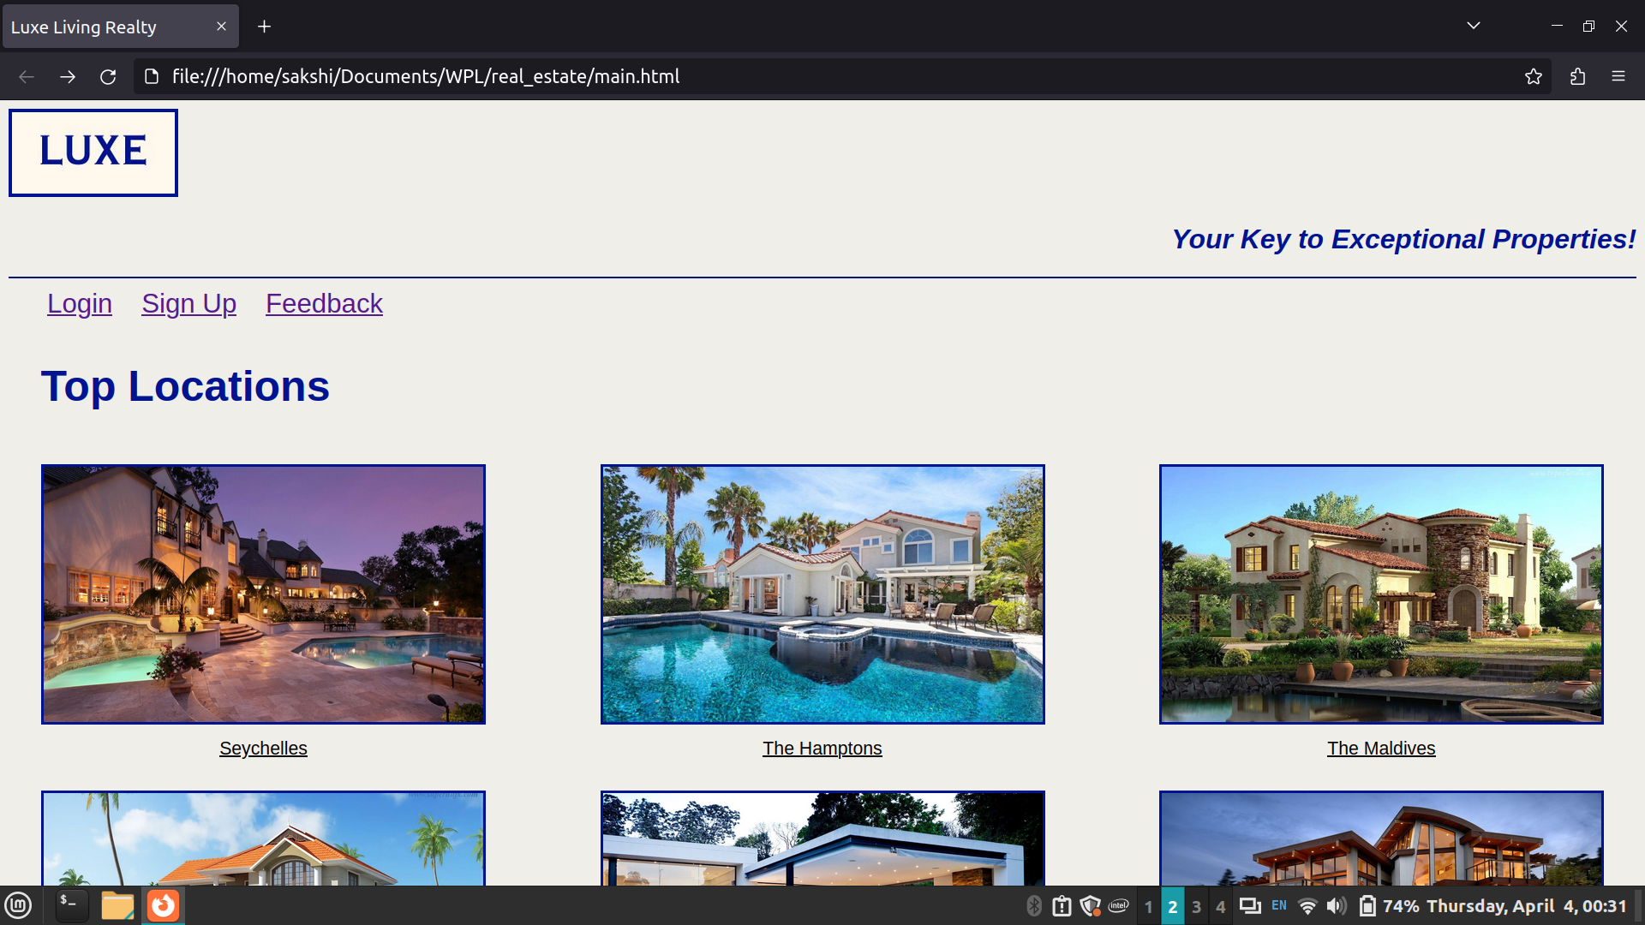

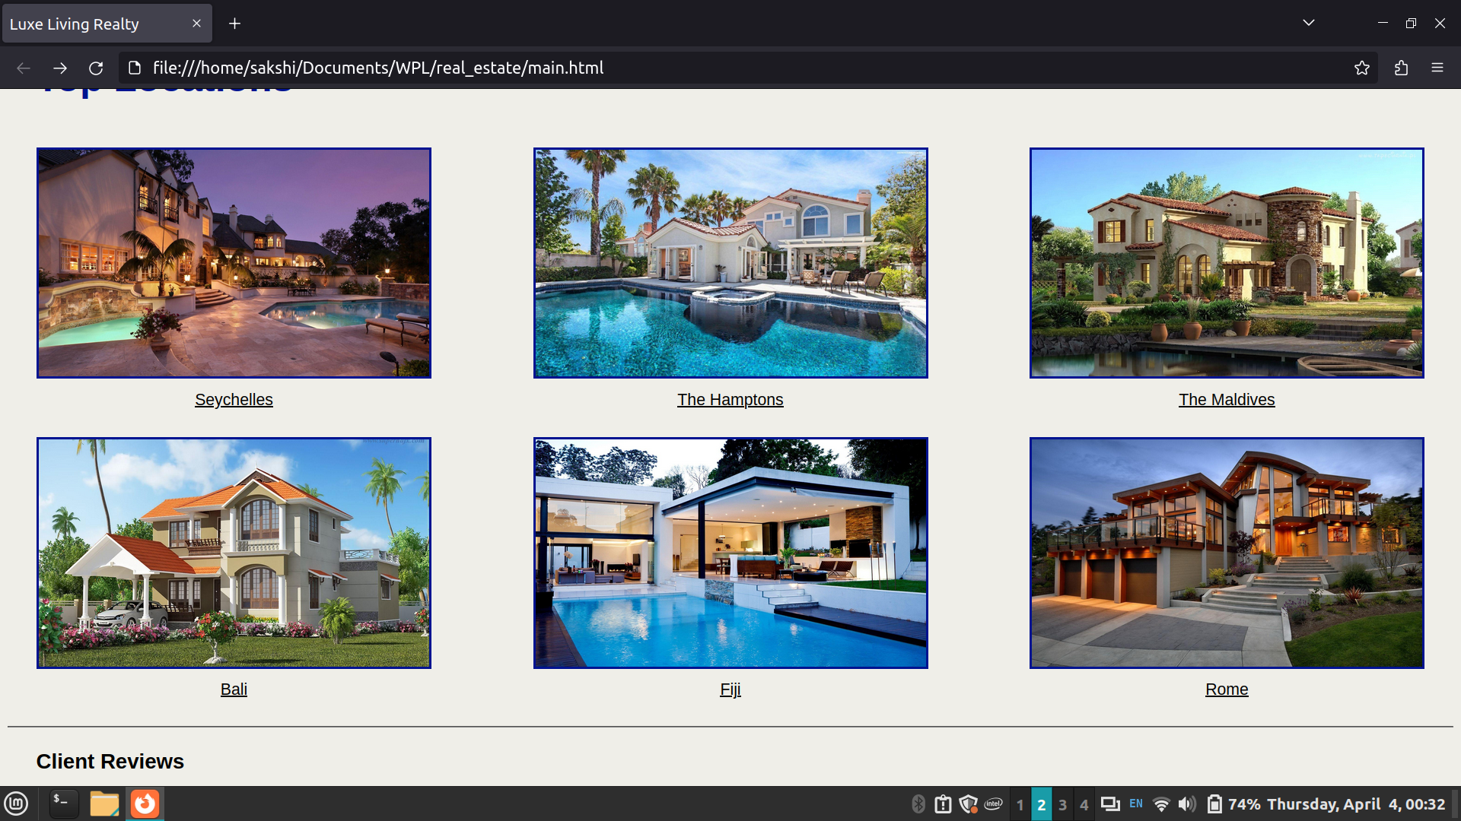

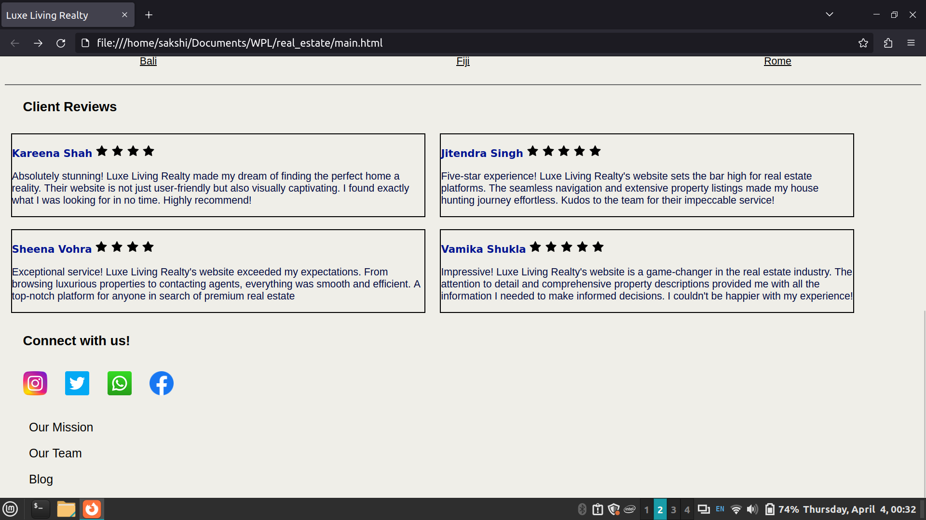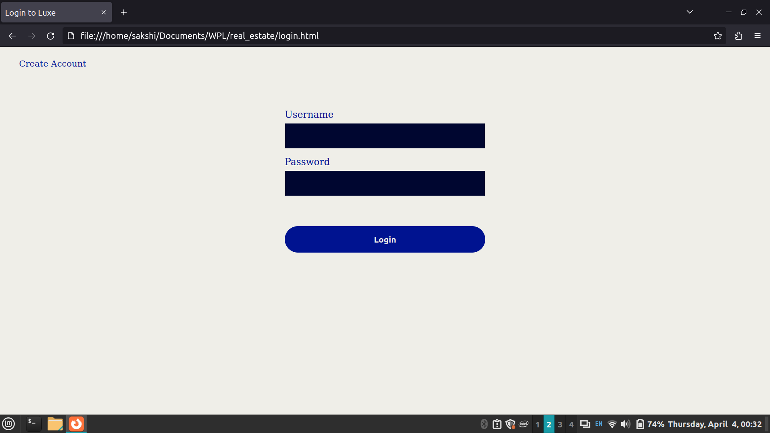

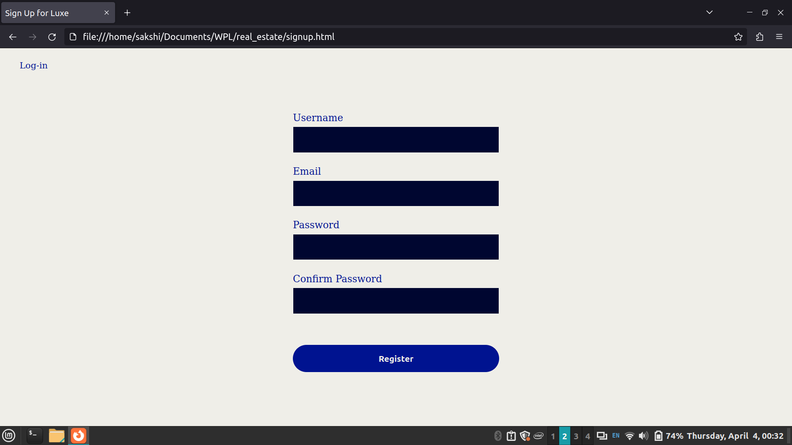

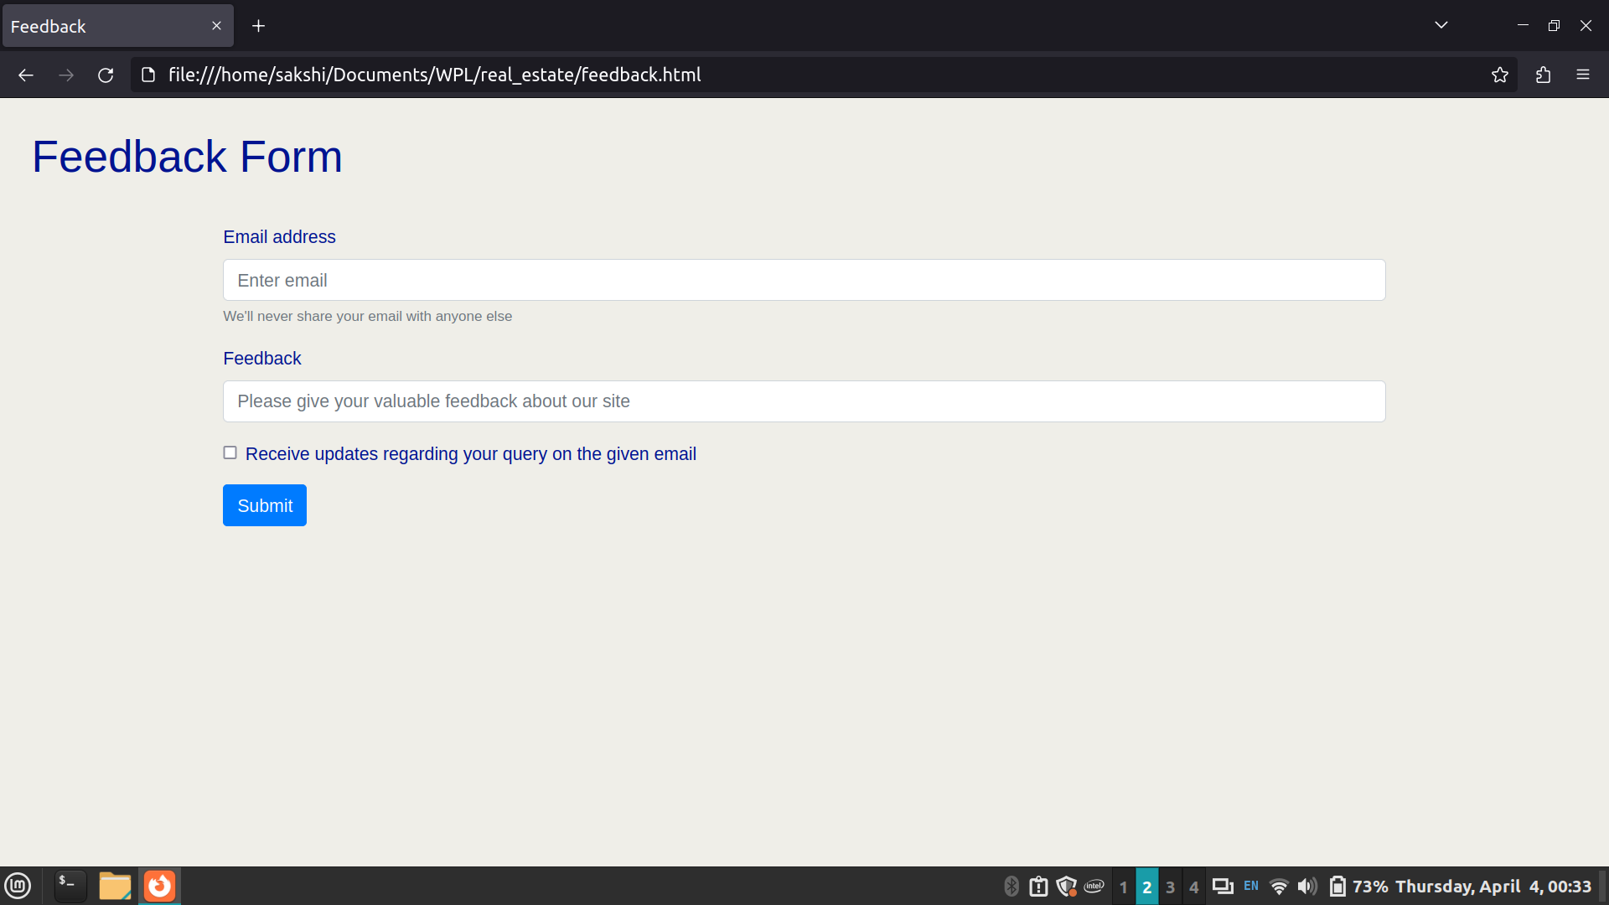

- BOOTSTRAP WEBSITE

<!DOCTYPE html>
<html lang="en">
<head>
<meta charset="UTF-8">
<meta name="viewport" content="width=device-width, initial-scale=1.0">
<title>Bootstrap Webpage</title>
<link href="https://stackpath.bootstrapcdn.com/bootstrap/4.5.2/css/bootstrap.min.css" rel="stylesheet">
<style>
.rounded-img {
border-radius: 50%;
}
</style>
</head>
<body>

<div class="container">
<div class="row">
<div class="col-md-12">
<h1>Bootstrap Webpage</h1>
<p>This is a basic example of a webpage created using Bootstrap.</p>
<div class="row">
<div class="col-md-4">
<img src="https://via.placeholder.com/150" class="img-fluid rounded-img" alt="Circle Image">
</div>
<div class="col-md-8">
<form class="form-inline my-2 my-lg-0">
<input class="form-control mr-sm-2" type="search" placeholder="Search" aria-label="Search">
<button class="btn btn-outline-success my-2 my-sm-0" type="submit">Search</button>
</form>
</div>
</div>
<nav aria-label="Page navigation example">
<ul class="pagination">
<li class="page-item"><a class="page-link" href="#">Previous</a></li>
<li class="page-item"><a class="page-link" href="#">1</a></li>
<li class="page-item"><a class="page-link" href="#">2</a></li>
<li class="page-item"><a class="page-link" href="#">3</a></li>
<li class="page-item"><a class="page-link" href="#">Next</a></li>
</ul>
</nav>
</div>
</div>
</div>

<script src="https://code.jquery.com/jquery-3.5.1.slim.min.js"></script>
<script src="https://cdn.jsdelivr.net/npm/@popperjs/core@2.5.4/dist/umd/popper.min.js"></script>
<script src="https://stackpath.bootstrapcdn.com/bootstrap/4.5.2/js/bootstrap.min.js"></script>
</body>
</html>

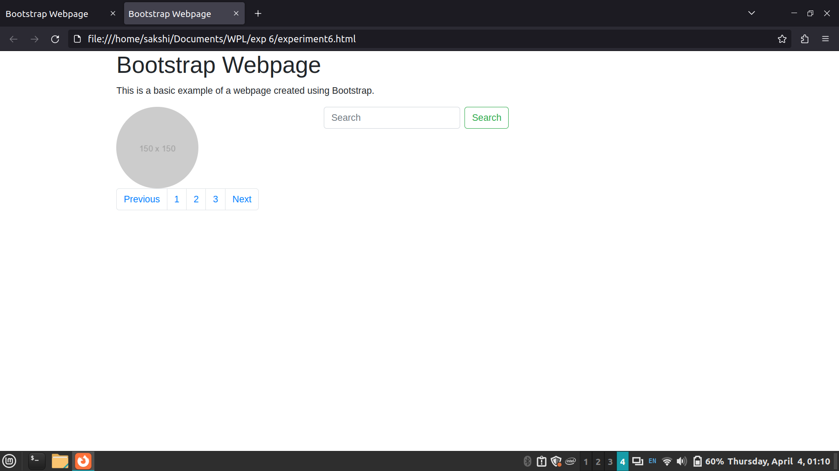

Post Lab Questions:
- What is the use of containers in bootstrap? Explain in detail.
Ans:
In Bootstrap, containers are a fundamental part of the layout system. They are used to wrap site contents and provide padding and margin to the content within. Containers ensure proper alignment and padding of the content, making the layout responsive and visually appealing across different devices and screen sizes.
Bootstrap provides two types of containers:
.container: This class provides a fixed-width container. The width of the container remains constant regardless of the screen size, ensuring that the content doesn't spread too wide on large screens. The container resizes as the screen size changes, but it maintains its fixed width.
.container-fluid: This class creates a full-width container that spans the entire width of the viewport. It adjusts its width dynamically based on the screen size, making it suitable for creating fluid layouts that adapt to different screen sizes.

- Name the classes to achieve the different button styles in bootstrap.
Ans:
Sure, here are the different button styles in Bootstrap:

1. Primary Button: .btn-primary
2. Secondary Button: .btn-secondary
3. Success Button: .btn-success
4. Danger Button: .btn-danger
5. Warning Button: .btn-warning
6. Info Button: .btn-info
7. Light Button: .btn-light
8. Dark Button: .btn-dark

These classes can be applied to <button> elements to apply the respective styles without any need for additional examples.

- Write details about the Bootstrap Grid system.
Ans:
The Bootstrap grid system is a powerful layout system that allows developers to create responsive and mobile-first layouts with ease. It is based on a 12-column grid layout, which can be customized to create complex and flexible layouts. The grid system is divided into rows and columns, and content is placed within these columns.

Key components of the Bootstrap grid system include:
- Container: As discussed earlier, the container wraps the content and provides padding and margin to ensure proper alignment and responsiveness.
- Rows: Rows are horizontal containers that hold columns. They ensure that columns are properly aligned and spaced within the container.
- Columns: Columns are the basic building blocks of the grid system. They are placed within rows and are used to organize and layout content. Bootstrap provides classes for defining the width of columns, such as col-, col-sm-, col-md-, col-lg-, and col-xl-, which determine how many columns a certain element should span across at different screen sizes.

